Computer Games AI Assignment 1 Report

We have included iostream so we can use it in the debugging of the program.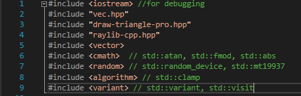

We are going to be using x and z vectors to allow the ai to move in all directions of the 2D screen.



This part of the program creates a random float between -1.0f and 1.0f which when multiplied by the size of the map will give us the platform of the hunt.

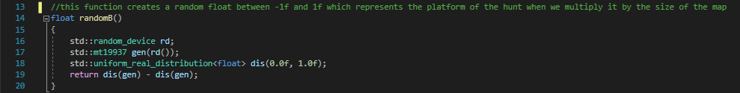

We are using two separate values to represent acceleration.

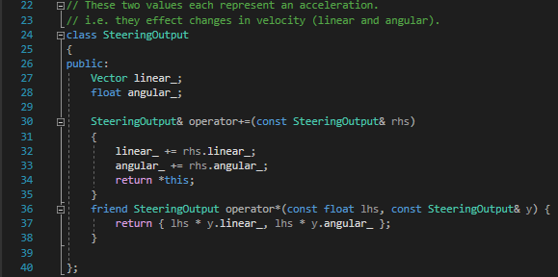

We are creating random called Kinematic

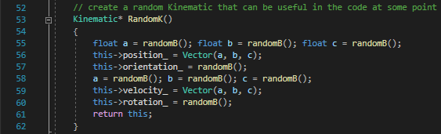

In this part of the program we are integrating linear and angular accelerations.

We are using Newton-Euler 1 simplification.

We exchanged the post-process and orientation because post-processing was “eating” the wander orientation during each update, making it impossible for it to complete properly without changing the update function or creating a new one from scratch. Since this works correctly we decided to keep it changed for now.

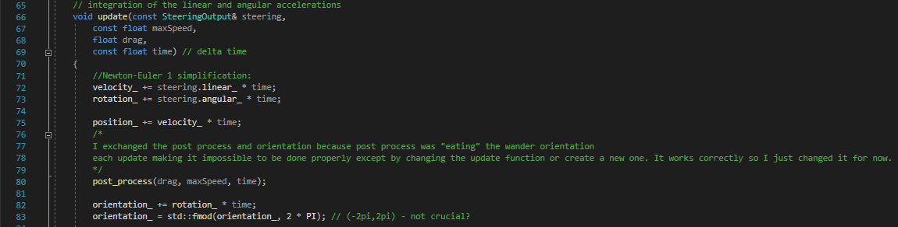

This part of the code makes it possible for the ships to move from any side of the map to the opposite side by passing by screen walls.

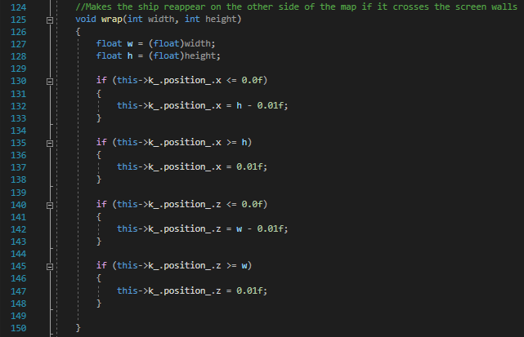

This piece of code creates a new prey once the previous one has been caught by the hunter. Also it should play sound when prey gets caught.

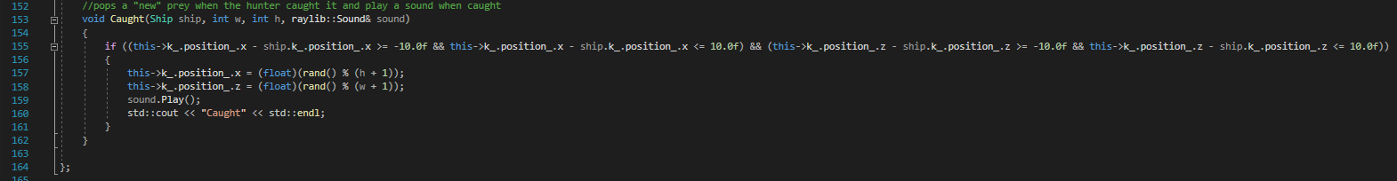

The targeted character (in this case prey) will randomly wander around the map, in general it moves straight while randomly changing the orientation angle. This should make the character move more smoothly and less weirdly.

We replaced the wander class as previously it limited character to being inside the screen, now the ai is allowed to touch screen wall so that it jumps to the opposite side of the screen.

We used the coursework version as it was much cleaner.

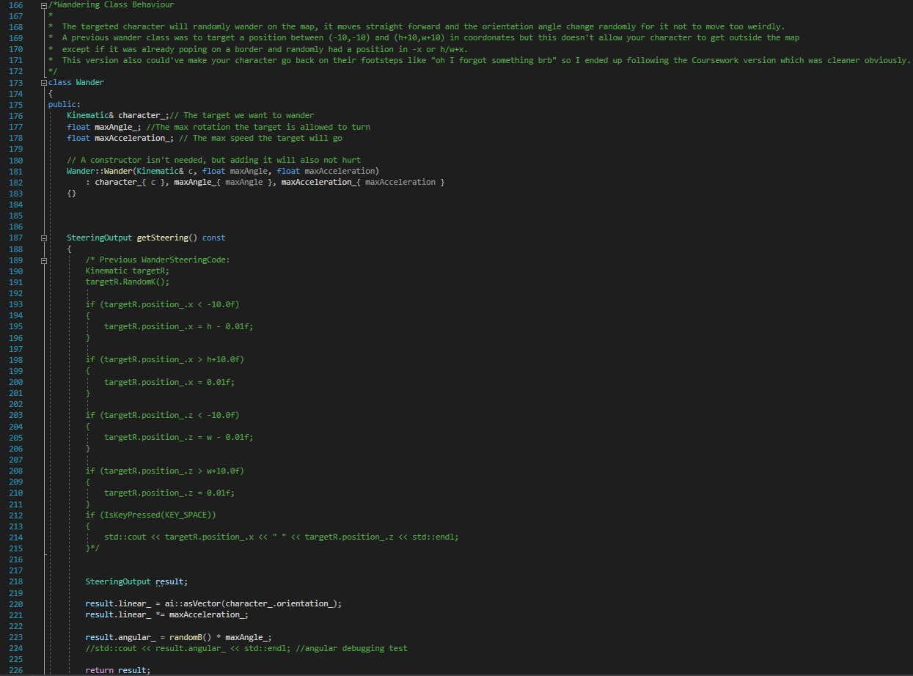

##This

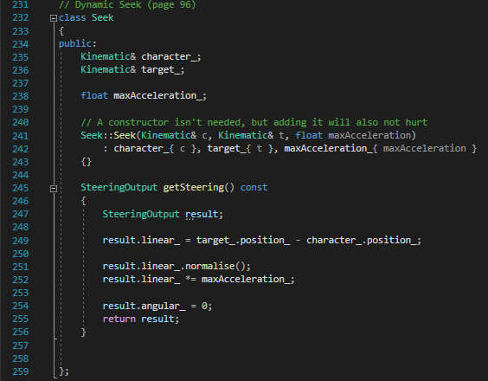

The top part of the code initializes sound and music. We have set 60fps target. And the screen dimensions are 1024 by 768.

We have also set colour for hunter and prey and their speed.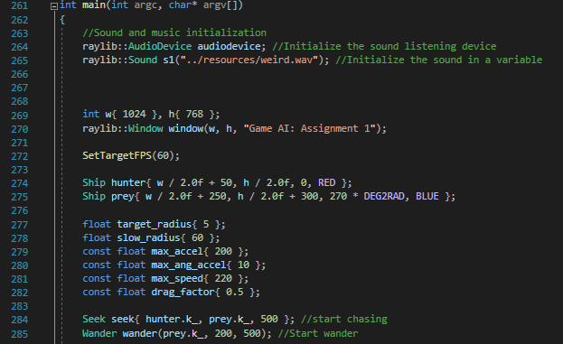This part of the code is detecting when window is closing.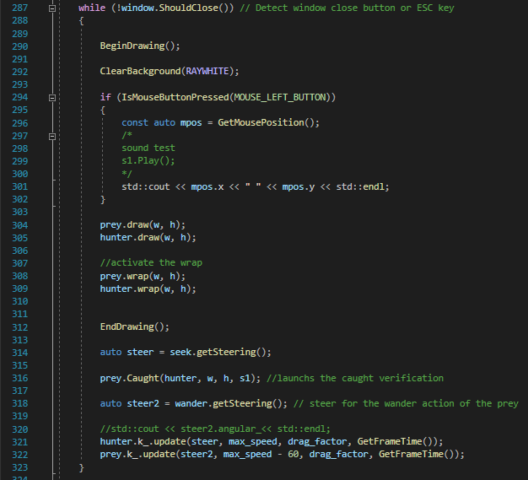

This video shows the assignment running.



In general the project is doing what it is supposed to do. There is prey and hunter. Prey is randomly wandering while hunter is coming towards prey until it catches prey. Then the prey is being respawned at random location of the map and hunter is pursuing the new target. There is also sound whenever hunter catches the prey.